

|  |
| --- |
| **MATHEMATICS DEPARTMENT 2015**  **Year 11 Specialist - Test Number 4**  **Real Numbers and Matrices** |



**Name: _______________________________ Teacher: __________________**



**Marks: 42**

**Time Allowed: 45 minutes**

**Instructions:** You arepermitted your calculator and 1 A4 page of notes.

_________________________________________________________________________

Part A

6 multiple-choice questions

1 mark each: 6 marks

Circle the correct answer.

1 The solution of 2x = 8 cannot be classified as:



A an irrational number



B an integer

C a real number

D an odd number

E a rational number



[1 mark]

2 3.85 does not equal:

**A** 

**B** 

C 

D 

E 3.9 [1 mark]



3 Irrational numbers can never be written as:

A infinite continued fractions.

B fractions of the form , *a* ∈ Qʹ and *b* ∈ Z.

C fractions of the form , where *a*, *b* ∈ Qʹ.

D fractions of the form , where *a*, *b* ∈ Z.



E fractions of the form , where *a* ∈ Z and *b* ∈ Qʹ.

[1 mark]

**4**  A counter example to show that if *a*2 + *b*2 = *c*2, then *a*, *b* and *c* have to be integer values is a false   
statement is:

A *a* = 3, *b* = 4 and *c* = 5



B *a* = , *b* =  and *c* = 



C *a* = 3, *b* = –4 and *c* = 5



D *a* =, *b* = and *c* = 



E *a* =, *b* =and *c* =



[1 mark]



**5** Consider the following matrix.



The order of the matrix is:

A 2

B 3

C 2 × 3



D 3 × 2

E 3 × 3

[1 mark]

6 Consider the matrix A = .

Matrix multiplication A × B is possible where B is matrix:

A 

B 

C 

D 



E 

[1 mark]

Part B

8 short answer questions

30 marks

**Show your working where appropriate to gain full marks.**

7 a Show that the set of positive integers is not closed under subtraction.



b Prove that the set of even natural numbers is closed under multiplication.



[1, 2: 3 marks]

8 Write  as a mixed number.



[1 marks]



9 Use a proof by contraposition to show that if x, y ∈ *Z* and x + y ≥ 9, then x ≥ 5 or y ≥ 5.



[3 marks]

10 Prove by mathematical induction that 34n – 1 is divisible by 8 for *n* ∈ *N*.



[5 marks]

11 Find the following:





[1 mark]

12 X = . Find X2 without the aid of a calculator.

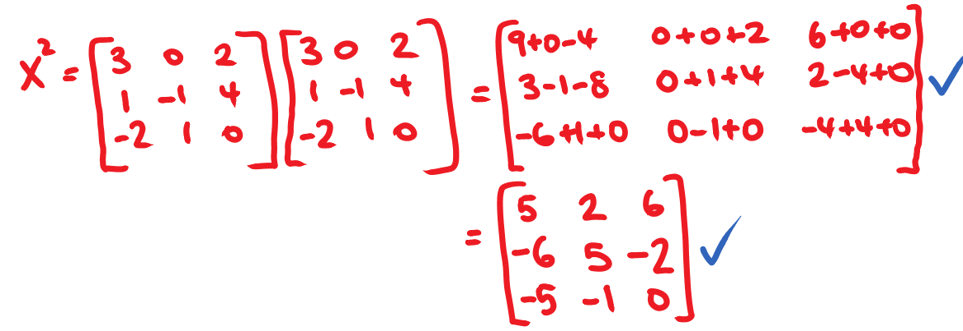

M = . Find $M^{-1}$ without the aid of a calculator



[2, 2: 3 marks]

13 Factorise each of the following matrix expressions, where possible.

a C 2+ 5C



b XYZ− X2Z2



c 2C2 + 6CD+ 3DC+ 9D2



[1, 2, 2: 5 marks]

14 Solve the following equations for X.

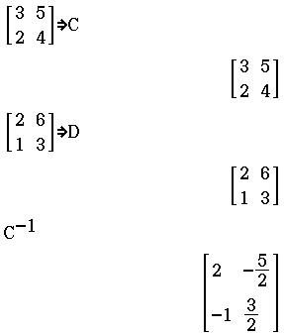a 



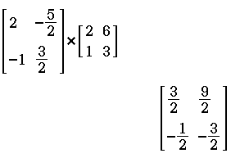



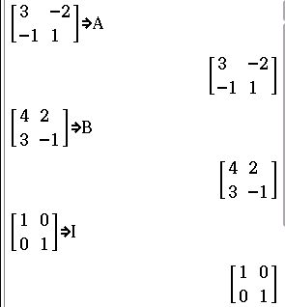b AX − 2IA + B = **I** − ABX, where A =  and B = 



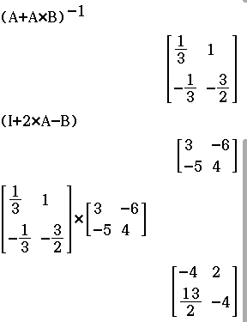



[3, 5: 8 marks]

Part C

2 analysis questions

6 marks

Show your working where appropriate.

15 How many prime numbers do you need to check to see if 193 is a prime number?



[1 mark]

16 Aaron, Byron and Callum all completed a multiple choice examination containing 40 problems.   
Callum completed all questions. The table shows the results of the examination and the marks awarded.

|  |  |  |  |
| --- | --- | --- | --- |
|  | Correct | Incorrect | Not attempted |
| Aaron | 30 | 6 | 4 |
| Byron | 32 | 7 | 1 |
| Callum | *x* | 40 − *x* | 0 |
| Marks awarded | 2 | −1 | 0 |

a Find .



bExplain what your answer to a represents.



cIf Callum scored the highest mark, use your answer in a to find his least number of correct answers.



[5 marks]



Total marks: 42

End of test